ECPHRASTIC POETRY ACTIVITY
PHYSICS

Using the given stimulus material, create the following types of poetry:
- Free verse
- Acrostic
- Cinquain
- Haiku
- Limerick
Remember to complete the following steps:
- View a stimulus image and identify a physics-related concept it evokes.

- If required, write down the concept, definition, law, formula etc.

- Identify a suitable poetry type and write the poem.

STIMULUS IMAGE 1
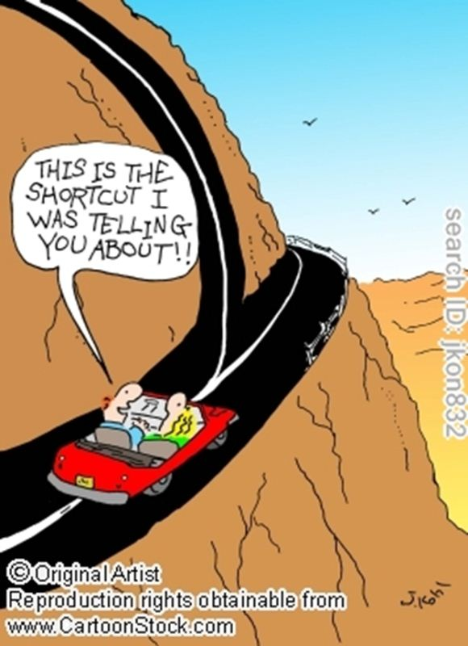
http://www.cartoonstock.com/newscartoons/cartoonists/jko/lowres/jkon832l.jpg
STIMULUS IMAGE 2
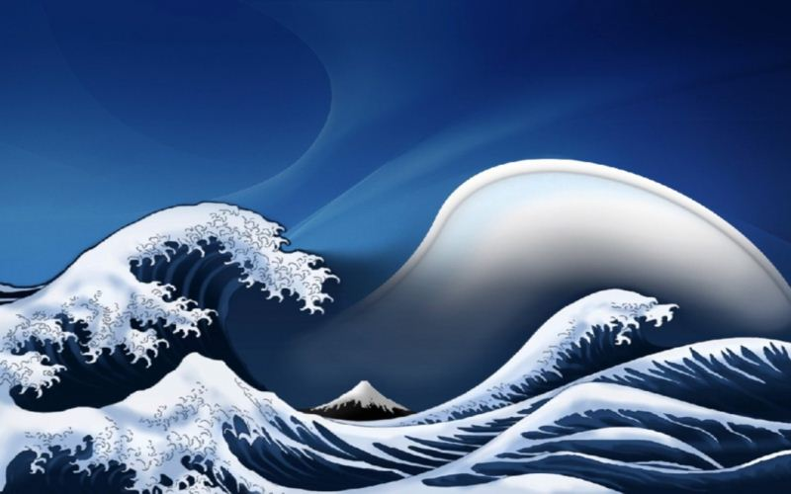
http://www.scenicreflections.com/files/Japanese_Waves_Wallpaper_dnwds.jpg

STIMULUS IMAGE 3
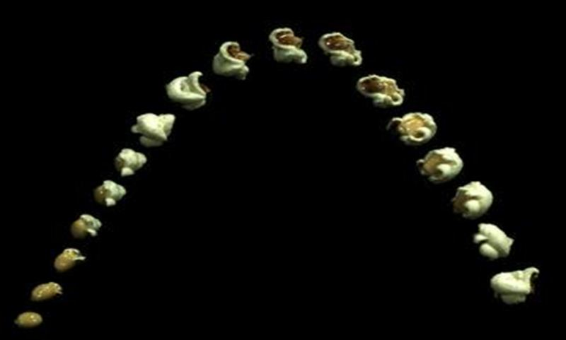
http://www.popcorn.org/Portals/0/Images/PoppinPopcorn.jpg

STIMULUS IMAGE 4
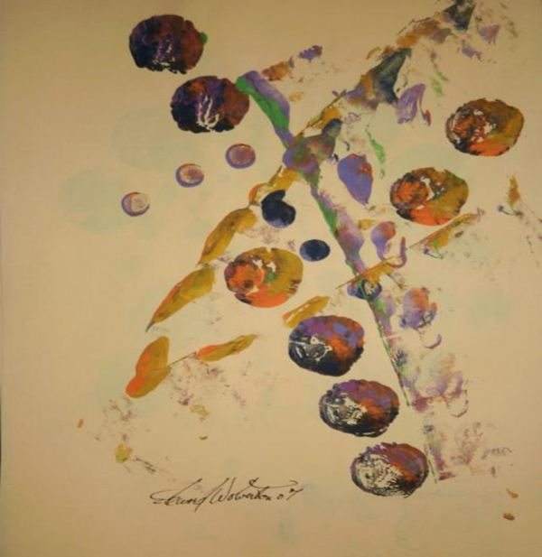
http://images.fineartamerica.com/images-medium/the-southern-cross-edward-wolverton.jpg

STIMULUS IMAGE 5
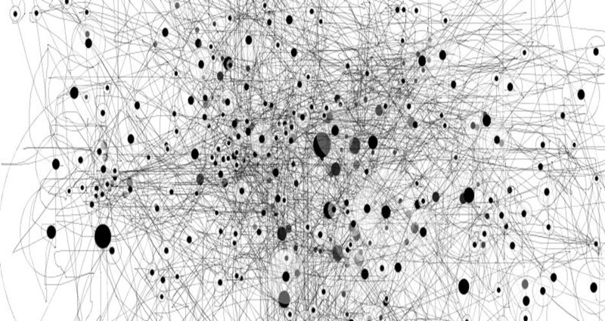
http://densityofspace.com/densitypaths.jpg

